36.65: For 650 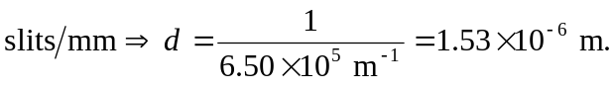
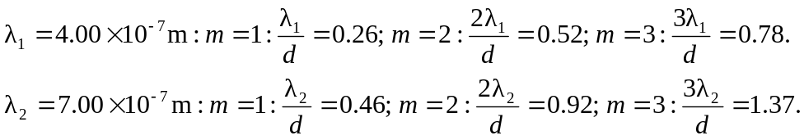
So the third order does not contain the violet end of the spectrum, and therefore only the first and second diffraction patterns contain all colors of the spectrum.

